COLÉGIO FAG

Disciplina: Português Professor: João Lima Turma: 6º

Nº
Aluno:
Data:

Material de apoio:
Caderno e apostila,
Lide: https://www.youtube.com/watch?v=QQvIJ_Se3Yc.

1 - Qual a estrutura do LIDE? E qual a importância do Lide na notícia?
_______________________________________________________________________________________________________________________________________________________________________________________________________________________________________

2 - Crie uma notícia usando o Lide de forma completa. Você escolherá o tema jornalístico. Lembre-se de, além de usar o Lide, deixar de forma completa sua reportagem/notícia ao leitor.
_______________________________________________________________________________________________________________________________________________________________________________________________________________________________________________________________________________________________________________________________________________________________________________________________________________________________________________________________________________________________________________________________________________________________________________________________________________________________________________________________________________________________________________________________________________________________________________________________________________________________________________________________________________________________________________________________________________________________________________________________________________________________________________________________________________________________________________________________________________________________________________________________________________________________________________________________________________________________________________________________________________________________________________________________________________________________________________________________________________________________________________________

3 - Analise a charge:
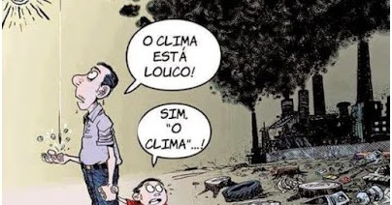
O que podemos deduzir a respeito dela?
____________________________________________________________________________________________________________________________________________________________________________________________________________________________________________________________________________________________________________________
4 - Analise os verbos nas seguintes frases de acordo com seu tempo verbal:
A - Perdemos o campeonato de vôlei desse ano.
___________________________________________________________________________
B- Que ele fale a verdade, pois estão esperando.
___________________________________________________________________________
C - Josias resumirá toda a história
___________________________________________________________________________

