

**Digite: Aylson Valeci Dalferth**

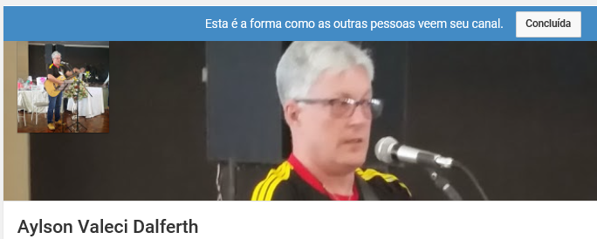

**Estes vídeos têm todo material explicativo sobre a matéria de Música.**

**Mande o seu vídeo, tocando flauta ou cantando tocando algum outro instrumento, ou fazendo outras atividades musicais…vou ficar muito feliz e vai ser uma forma do Professor matar a saudade de vocês.**

 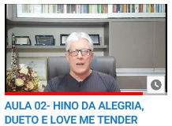

**Os alunos poderão gravar vídeo das músicas estudadas, é muito importante os pais estimularem os filhos a treinar as Músicas já estudadas é uma forma legal de ocupar o tempo e fazer com o Dia fique mais prazeroso**

 45-9.9941-4546

**E Receba muitos:**

[](https://www.google.com.br/imgres?imgurl=https%3A%2F%2Fimages-na.ssl-images-amazon.com%2Fimages%2FI%2F81GhJuX-uRL._SY355_.png&imgrefurl=https%3A%2F%2Fwww.amazon.com%2FBest-Emoji-Stickers-WhatsApp-WAStickersApp%2Fdp%2FB07M9HJRHL&tbnid=By_LgUW0Rd_NxM&vet=12ahUKEwjQ8sLlsbPoAhXxC9QKHRJWDEQQMyg-egUIARCOAg..i&docid=tph5Nb2y_bqOpM&w=355&h=355&q=emotion%20whatsapp&ved=2ahUKEwjQ8sLlsbPoAhXxC9QKHRJWDEQQMyg-egUIARCOAg) [](https://www.google.com.br/url?sa=i&url=https%3A%2F%2Fbr.pinterest.com%2Fzeliaspti%2Femoticons-carinhas-significados%2F&psig=AOvVaw3hajFkTb_Dhm8C_QwCRqHj&ust=1585149296089000&source=images&cd=vfe&ved=0CAIQjRxqFwoTCLCIs8Gzs-gCFQAAAAAdAAAAABAD) [](https://www.google.com.br/url?sa=i&url=https%3A%2F%2Fwww.pinterest.ph%2Fpin%2F329748003952610037%2F&psig=AOvVaw3hajFkTb_Dhm8C_QwCRqHj&ust=1585149296089000&source=images&cd=vfe&ved=0CAIQjRxqFwoTCLCIs8Gzs-gCFQAAAAAdAAAAABAI) [](https://www.google.com.br/url?sa=i&url=https%3A%2F%2Ftwitter.com%2Fcarinhafeliz10&psig=AOvVaw3hajFkTb_Dhm8C_QwCRqHj&ust=1585149296089000&source=images&cd=vfe&ved=0CAIQjRxqFwoTCLCIs8Gzs-gCFQAAAAAdAAAAABAO) [](https://www.google.com.br/url?sa=i&url=https%3A%2F%2Fbr.pinterest.com%2Fzeliaspti%2Femoticons-carinhas-significados%2F&psig=AOvVaw3hajFkTb_Dhm8C_QwCRqHj&ust=1585149296089000&source=images&cd=vfe&ved=0CAIQjRxqFwoTCLCIs8Gzs-gCFQAAAAAdAAAAABAU) [](https://www.google.com.br/url?sa=i&url=https%3A%2F%2Fwww.shutterstock.com%2Fpt%2Fimage-vector%2Femoticon-clapping-99603305&psig=AOvVaw3hajFkTb_Dhm8C_QwCRqHj&ust=1585149296089000&source=images&cd=vfe&ved=0CAIQjRxqFwoTCLCIs8Gzs-gCFQAAAAAdAAAAABAa) [](https://www.google.com.br/url?sa=i&url=https%3A%2F%2Fbr.depositphotos.com%2Fstock-photos%2Ffelicidade-emoji.html&psig=AOvVaw3hajFkTb_Dhm8C_QwCRqHj&ust=1585149296089000&source=images&cd=vfe&ved=0CAIQjRxqFwoTCLCIs8Gzs-gCFQAAAAAdAAAAABAj) [](https://www.google.com.br/url?sa=i&url=https%3A%2F%2Fbr.depositphotos.com%2Fvector-images%2Fa-rir.html&psig=AOvVaw3hajFkTb_Dhm8C_QwCRqHj&ust=1585149296089000&source=images&cd=vfe&ved=0CAIQjRxqFwoTCLCIs8Gzs-gCFQAAAAAdAAAAABAv) [](https://www.google.com.br/url?sa=i&url=https%3A%2F%2Fwww.pinterest.ch%2Fpin%2F726416614873894919%2F&psig=AOvVaw3hajFkTb_Dhm8C_QwCRqHj&ust=1585149296089000&source=images&cd=vfe&ved=0CAIQjRxqFwoTCLCIs8Gzs-gCFQAAAAAdAAAAABA1) [](https://www.google.com.br/url?sa=i&url=https%3A%2F%2Fwww.gratispng.com%2Fpng-7co7a8%2F&psig=AOvVaw1bbBa1O6t7FD--aZ6zX6zW&ust=1585150050999000&source=images&cd=vfe&ved=0CAIQjRxqFwoTCNDy3KK2s-gCFQAAAAAdAAAAABAD) [](https://www.google.com.br/url?sa=i&url=https%3A%2F%2Fwww.pngfuel.com%2Ffree-png%2Frypwm&psig=AOvVaw1bbBa1O6t7FD--aZ6zX6zW&ust=1585150050999000&source=images&cd=vfe&ved=0CAIQjRxqFwoTCNDy3KK2s-gCFQAAAAAdAAAAABAK) [](https://www.google.com.br/url?sa=i&url=https%3A%2F%2Fwww.pngfind.com%2Fmpng%2Fwmxbho_resultado-de-imagen-para-adult-emoticons-like-smile%2F&psig=AOvVaw1bbBa1O6t7FD--aZ6zX6zW&ust=1585150050999000&source=images&cd=vfe&ved=0CAIQjRxqFwoTCNDy3KK2s-gCFQAAAAAdAAAAABAQ)